Lab Exercise 20- ECR and ECS

Step 1: Create AWS account & Configure credentials.
Before pushing Docker Images, AWS needs authentication.

- Log into the AWS console.
- Create a Access key and secret key under IAM user.
- Configure AWS CLI:

Step 2: Create a Private Repository in ECR:
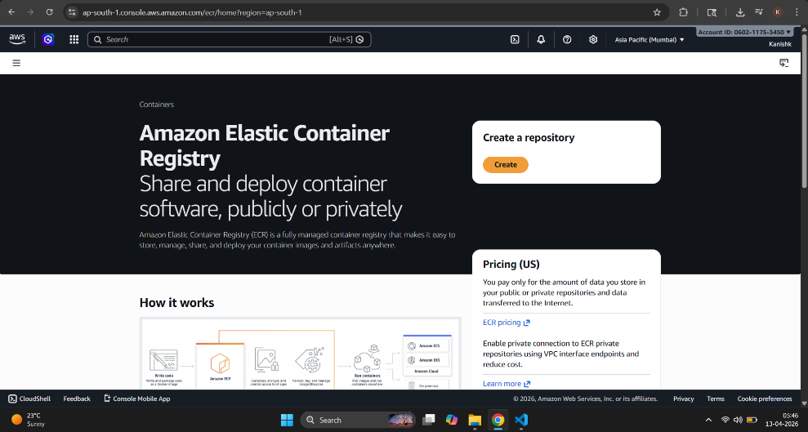
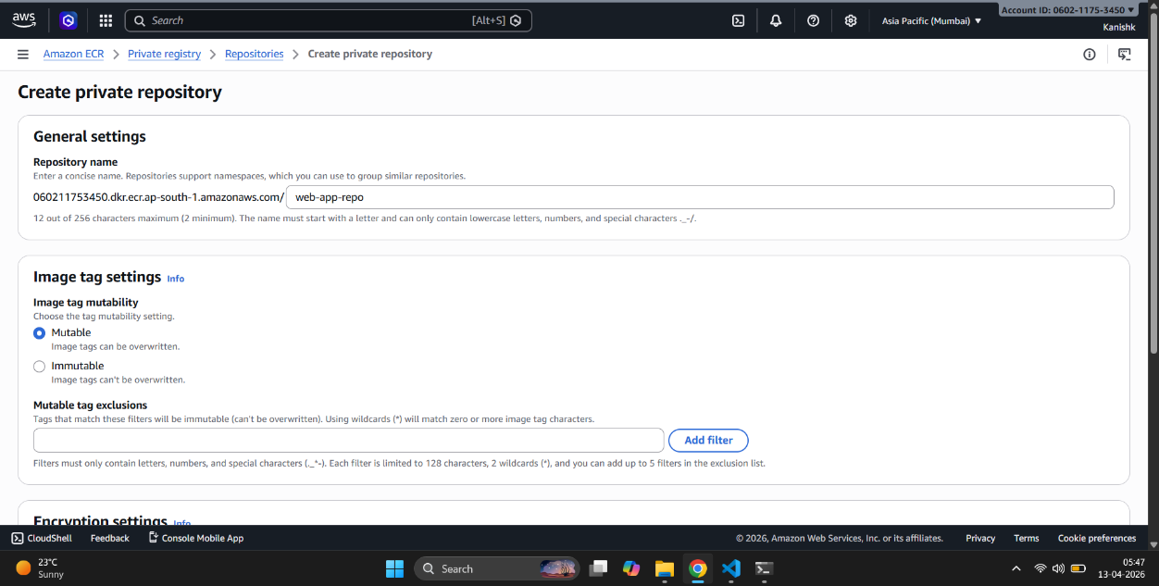
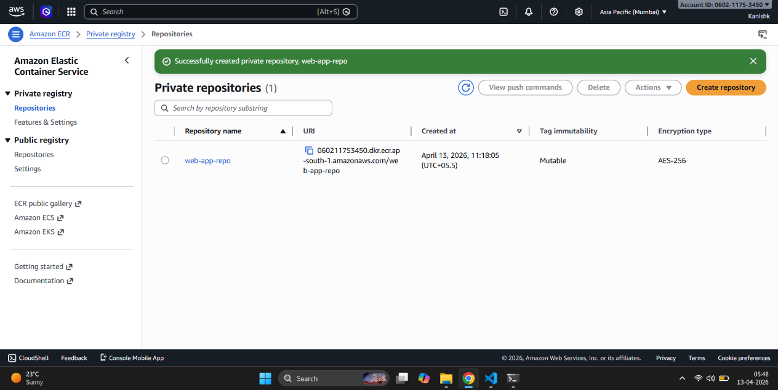

Step 3: Authenticate Docker with AWS and build Dockerfile:
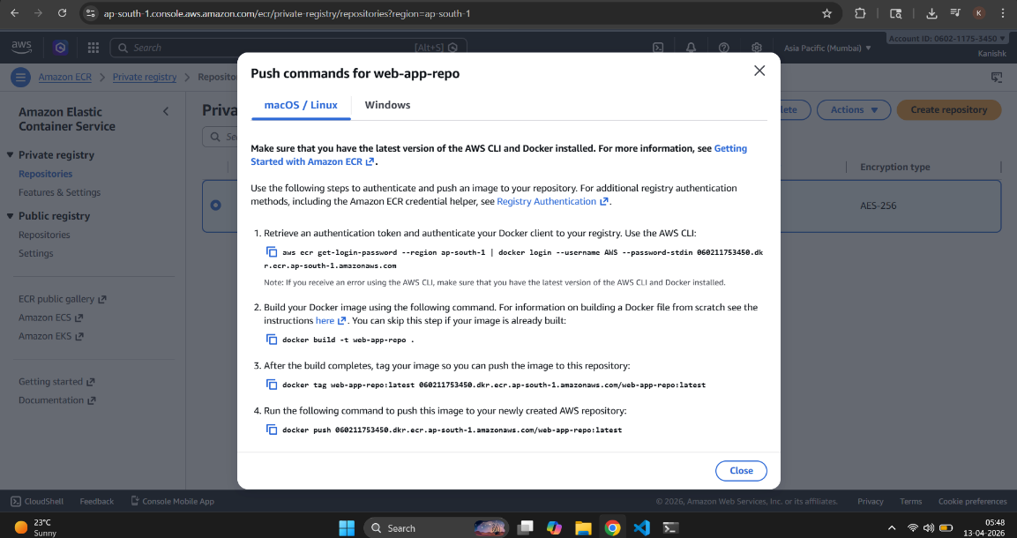
Step 4: Tag the Image and push it to the ECR:
Step 5: Create a ECS cluster:
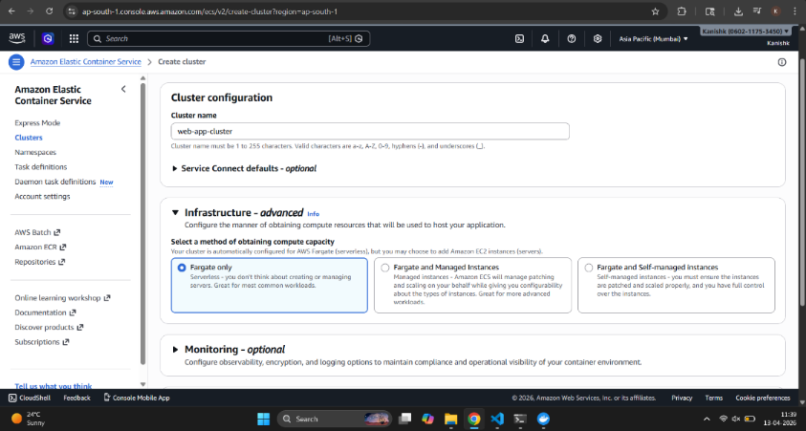
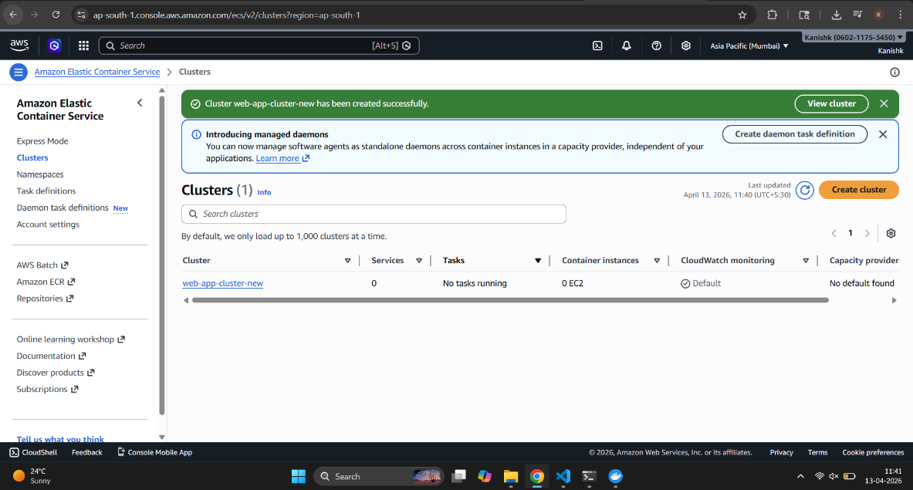
Step 6: Create Task Definition:
This is the blueprint for the container.
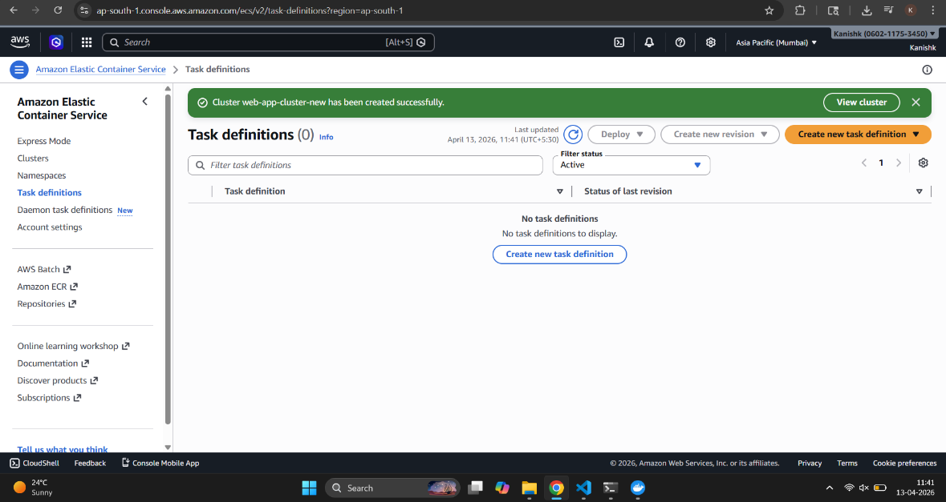
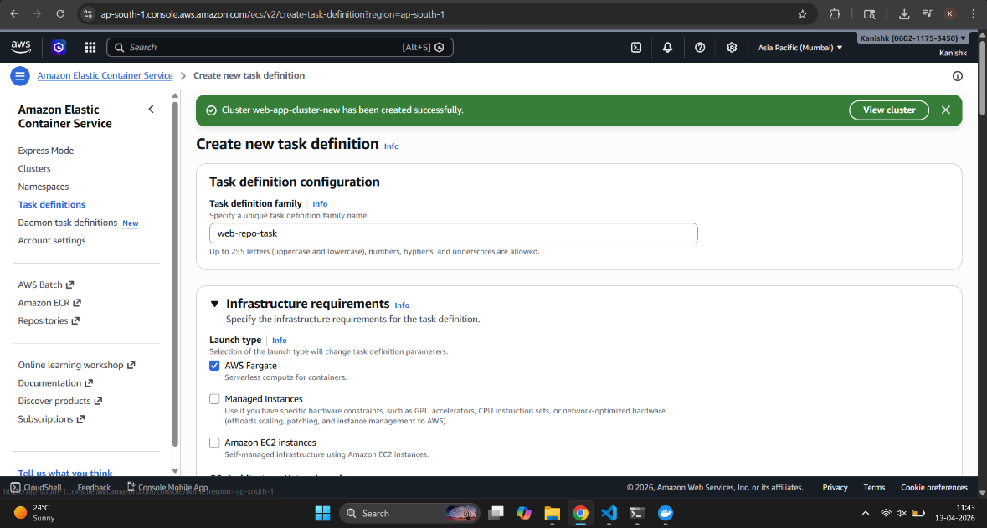
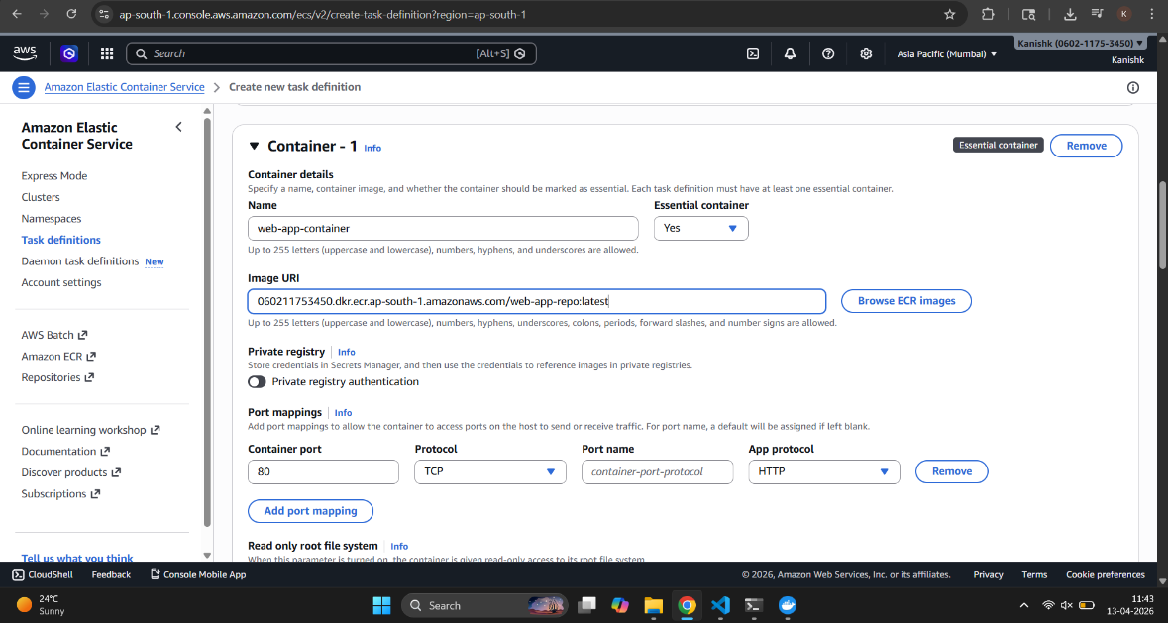
Step 7: Create Service;
Keeps container running continuously. Maintains desired number of instances.
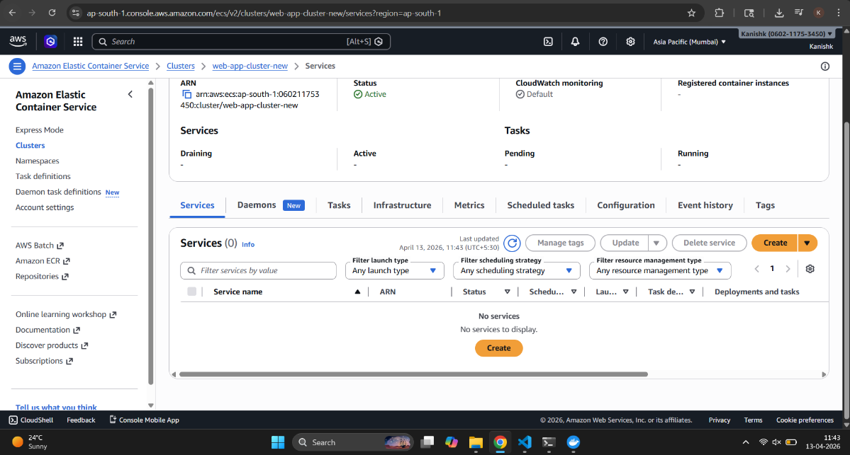
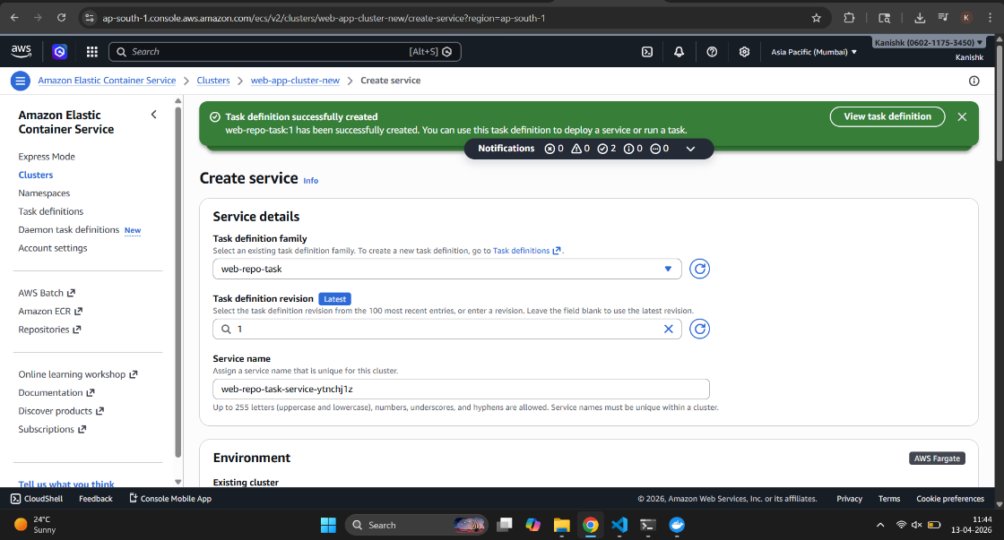
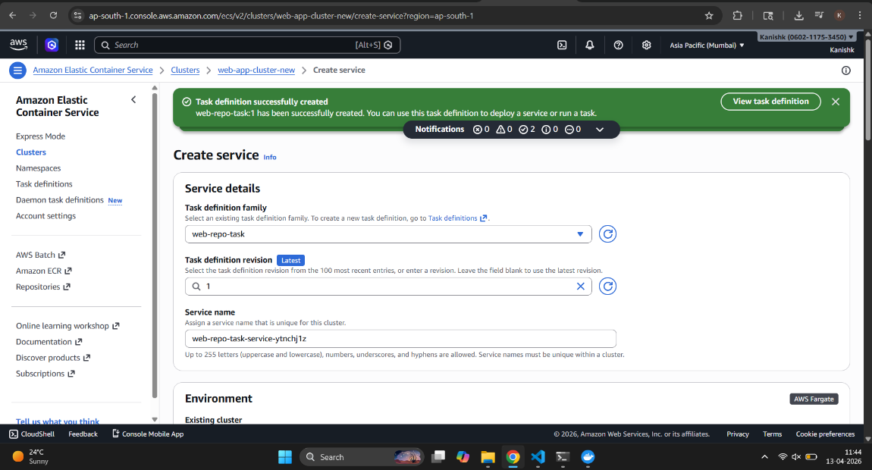
Step 8: Configure Networking:
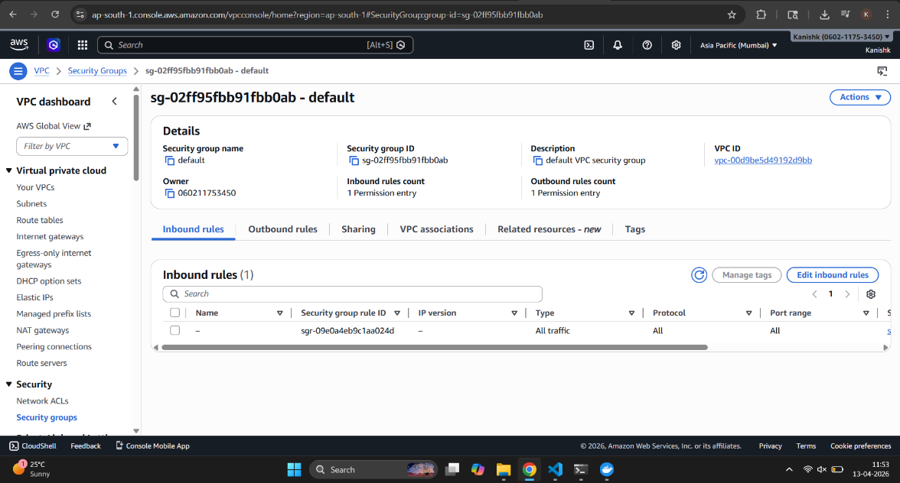
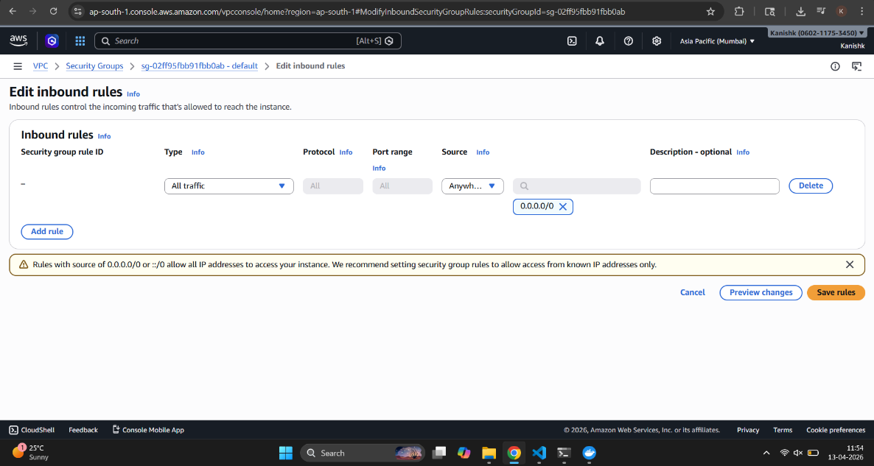
Step 9: Access Application
🔹 Final step:
- Copy Public IPv4
- Open in browser:
